**To install postman: -**

<https://www.getpostman.com/downloads/>

1. **CLICK ON DOOWNLOAD THE APP**

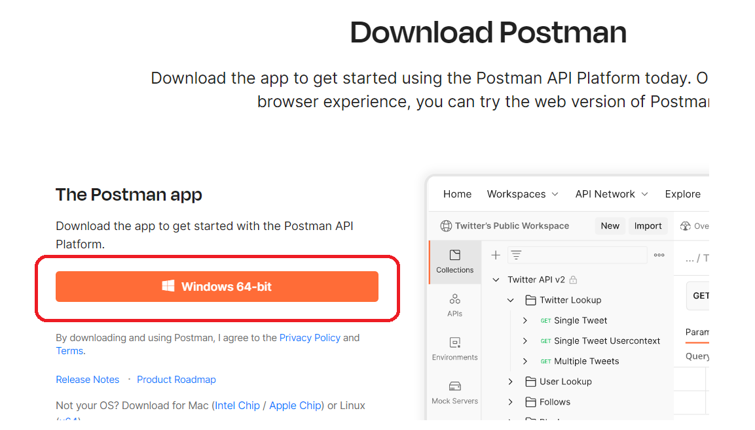

1. **After downloading below file double click on it**

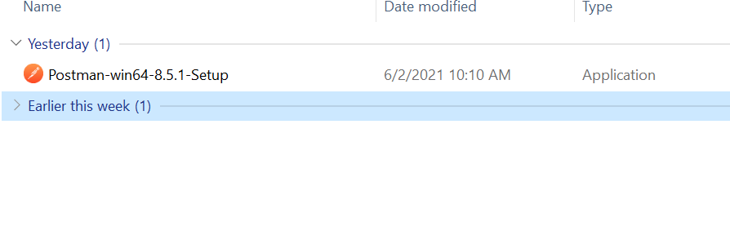

1. **AFTER INSTLLING IT WILL ASK CREATE ACCOUNT WINDOW, CLOSE THIS WINDOW AND REOPEN POSTMAN**

